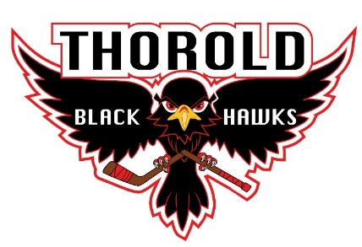
THOROLD AMATEUR ATHLETIC ASSOCIATION

REFUND POLICY
2023 2024

Refunds

- NO REFUNDS AFTER NOVEMBER 05, 2023
- All withdrawal requests must be submitted in writing to the registrar@thoroldminorhockey.com
- Any refunds prior to November 05, 2023 will be subject to a $50.00 administration fee and subject to a fee of proration of used ice for that division as well as any supplied uniform costs.
- Any refunds are also subject to Credit Card Fees incurred from original point of sale and refund. These fees are charged over and above admin and etc. above
- Late fees, Try out Fees are non-refundable.
- Please see our refund policy for “Season Ending Refund” for more detailed information in respect to hockey related injuries during the season
- ANY INTERUPTION OF SEASON DUE TO PUBLIC HEALTH WILL BE REVEIWED AT THAT TIME.

